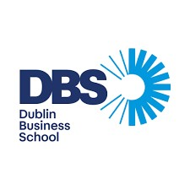
Name: Gokul Shiva Kumar (20097813)
Course Title: M.Sc. Cyber Security
Lecturer Name: Swati Dongre
Module/Subject Title: Advanced Programming Techniques
Assignment Title: CA_ONE_ (30%)
No. of Words: 744

Table of Contents

Introduction .............................................................................................................................3

Task 1: Churros Ordering System (C#) .............................................................................................................................3

Screenshot Placement:

Task 2: Periodic Table Application (C#) .............................................................................................................................4

3.1 Screenshot Placement:

Task 3: Client-Server Registration System (Python) ……………………………………………………………………….………………….…….…...4

Screenshot Placement:

Task 4: Web Scraping Application (Python) ..........................................................................................................................5

Screenshot Placement:

GitHub and CI/CD Integration .........................................................................................................................6

6.1 Screenshot Placement:

Conclusion .........................................................................................................................7

- Introduction
This report presents the development and implementation of four programming tasks using C# and Python. The assignment focuses on object-oriented programming concepts, data structures, client-server communication, and web scraping. The project is structured into two main sections: C# applications (Tasks 1 and 2) and Python applications (Tasks 3 and 4). Each task was designed to simulate real-world scenarios and demonstrate practical programming skills.

- Task 1: Churros Ordering System (C#)
This task involves the development of a console-based application for a food truck that sells churros. The system allows the stall owner to manage customer orders efficiently using a menu-driven interface.
The application was implemented using object-oriented principles such as classes, objects, encapsulation, constructors, and properties. Two main classes were created: Order and Churros. The Order class manages attributes such as order details, quantity, bill amount, and order number. Methods such as place_order(), pay_bill(), and collect_order() were implemented to handle core operations. The Churros class defines the available menu items and their prices.
A queue data structure was used to manage customer orders, ensuring a first-in-first-out (FIFO) system. This accurately reflects real-world queue handling in food services. The pay_bill() method calculates the total cost based on selected items and quantity, and a unit test was implemented to validate its correctness.

2.1 Screenshot Placement:
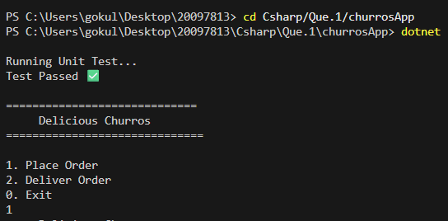
fig 2.1.1: Menu interface
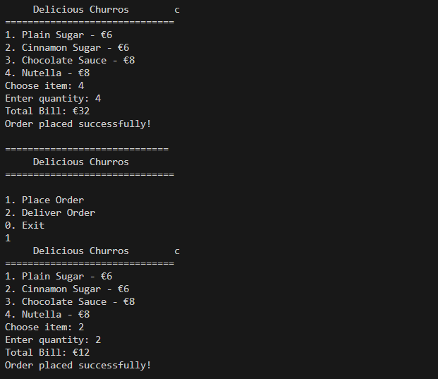
fig 2.1.2: Order placement
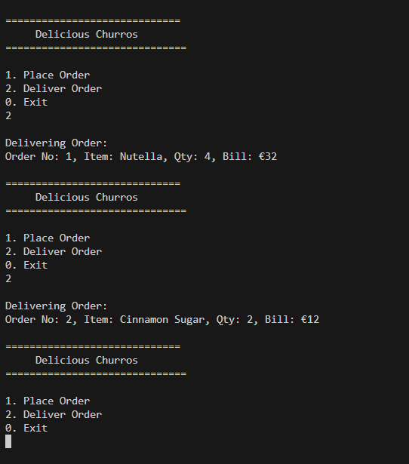
fig 2.1.3: Order delivery process

- Task 2: Periodic Table Application (C#)
This task required storing and retrieving information about the first 30 elements of the periodic table. A suitable data structure, such as a dictionary, was used to map atomic numbers to element details.
The program prompts the user to enter an atomic number and displays relevant information, including element name and classification. The application continues running until the user chooses to exit.
The design ensures efficient lookup and retrieval of data, demonstrating the use of data structures in solving real-world problems. Input validation was also implemented to handle incorrect entries.
3.1 Screenshot Placement:
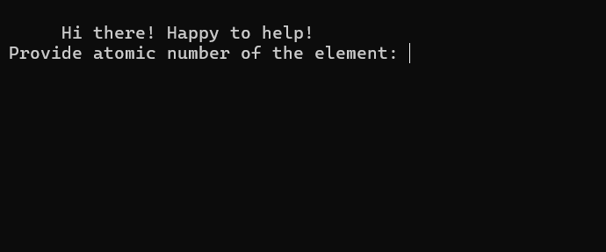
fig 3.1.1: User input (atomic number)
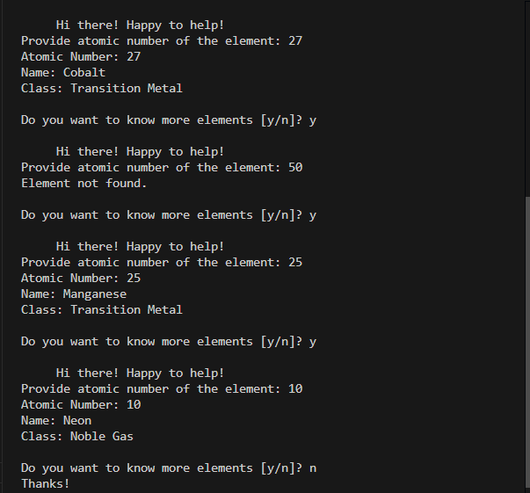fig 3.1.2: Output displaying element details

- Task 3: Client-Server Registration System (Python)
This task involves developing a client-server application using TCP protocol. The system simulates a car rental registration process where users provide personal details such as name, address, PPS number, and driving license information.
The client application collects user input and sends it to the server. The server processes the data, stores it in a database (file-based storage), and generates a unique registration ID. This ID is then sent back to the client.
Socket programming was used to establish communication between the client and server. The server runs continuously and handles incoming connections, while the client interacts with the user.
4.1 Screenshot Placement: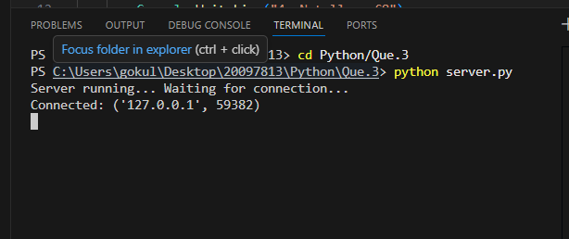Fig 4.1.1: Server terminal showing connection established
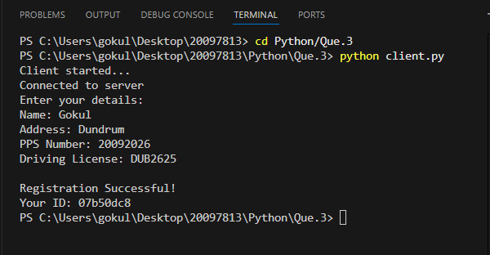Fig 4.1.2: Client terminal showing user input and received registration ID
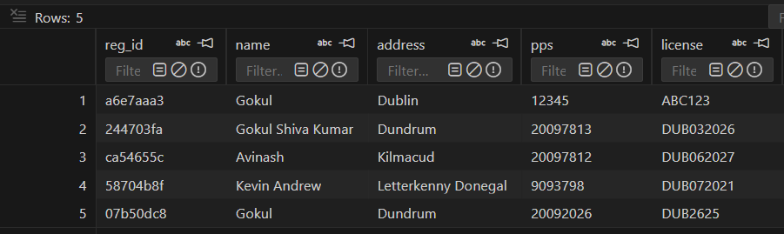
Fig 4.1.3: Customer Database showing user Data
- Task 4: Web Scraping Application (Python)
This task focuses on extracting data from a website using Python. The target webpage contains book details such as name, price, and rating. The requests and Beautiful Soup libraries were used to fetch and parse the HTML content.
The program extracts relevant data and stores it in a CSV file named books.csv. After storing the data, the program reads the CSV file and displays the contents in the terminal.
This task demonstrates data extraction, file handling, and automation using Python.
5.1 Screenshot Placement:
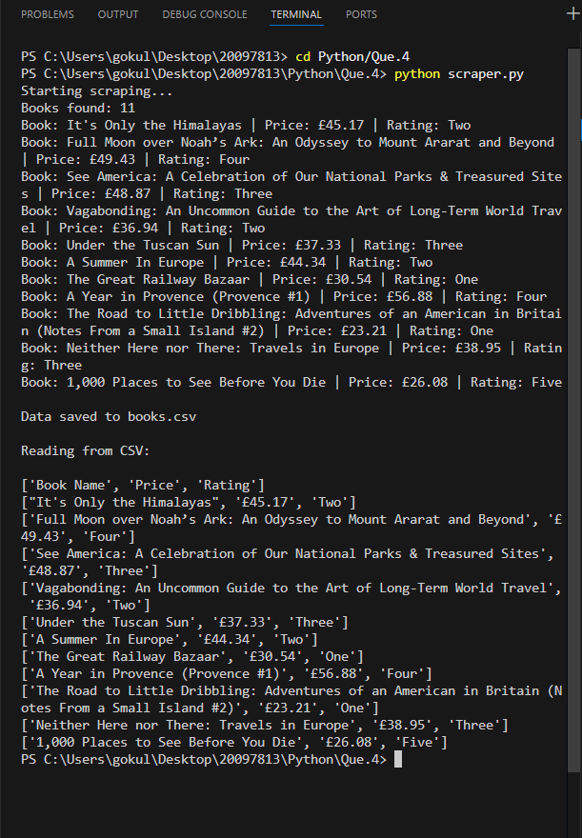Fig 5.1.1: Terminal output showing scraped data
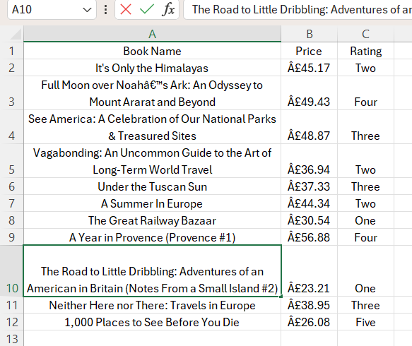Fig 5.1.2: CSV file content (books.csv)

- GitHub and CI/CD Integration
The project was managed using Git and hosted on GitHub. Multiple commits were made to track progress throughout development. A GitHub Actions workflow was implemented to automate the build and execution process.
The workflow includes:
- Running the Python scraper
- Building the C# application
- Ensuring code integrity on every push
This demonstrates knowledge of version control and continuous integration practices.
6.1 Screenshot Placement:
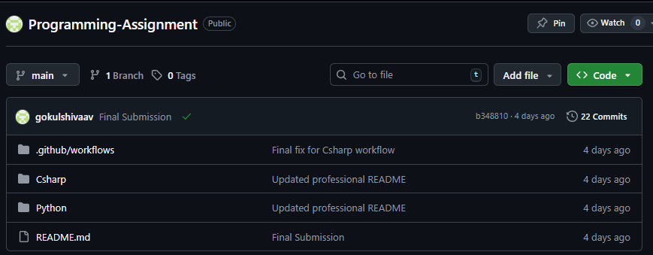fig 6.1.1: GitHub repository
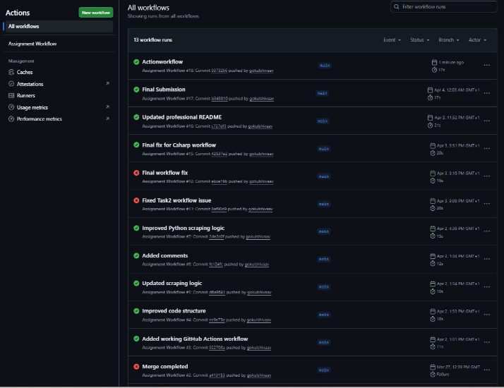
Fig 6.1.2: Actions tab showing successful workflow (green status)

- Conclusion
This assignment successfully demonstrates the application of programming concepts across multiple domains. C# was used to implement structured, object-oriented applications, while Python was used for networking and data extraction tasks. The integration of GitHub Actions further enhances the project by introducing automation and continuous integration.
Overall, the project highlights problem-solving skills, software design principles, and the ability to work with multiple technologies effectively.

- References:

- GitHub Link:
https://github.com/gokulshivaav/Programming-Assignment.git

